Solar and Our Surroundings

Does solar make noise?
Though tracking motors and inverters may make a soft humming sound, this noise is inaudible from 50-150 feet outside the solar enclosure. Noise associated with solar panels is limited to their construction and removal, which are brief periods over the course of a solar farm’s life.

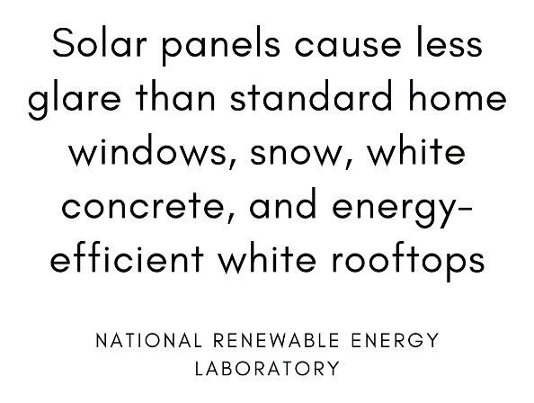
Does solar create glare?
Even though they look somewhat shiny, PV solar modules must absorb light rather than reflect it. Any reflected light cannot be converted into electricity, so solar panels are designed to ensure minimal reflection. Solar farms are often installed near airports, demonstrating the lack of glare associated with PV modules.

What are setbacks?
Solar setbacks are distancing requirements that separate solar projects from residences and private property. Ground-mounted solar projects must be sited a certain distance from homes to ensure visibility and access, traffic safety, ventilation, and vegetation management. Setbacks are typically determined locally, allowing communities to determine the best practices for their area and landscape.

What is screening?
Screening can provide visual cover of a solar project, minimizing disruption to surrounding scenery, especially in historic areas. Screening often consists of greenery; hedges, bushes and trees. It should be noted that screening requirements can block sunlight and decrease the efficiency of solar installments, with over-regulation being detrimental to our ability to develop vital solar projects.

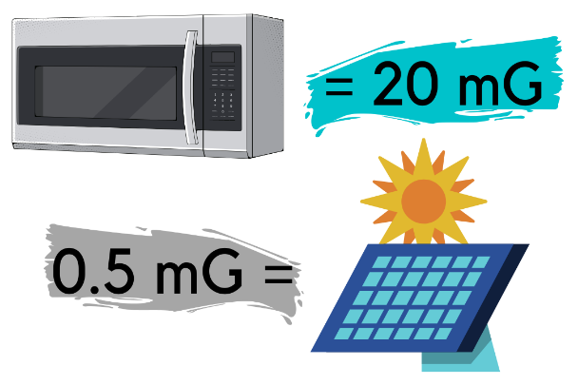
What is EMF and how does it relate to solar?
Electromagnetic Fields (EMFs) are produced by solar panels at levels similar to those created by household appliances. Solar panels generate non-ionizing electromagnetic fields (EMF), which are different from the ionizing radiation produced by x-rays. Non-ionizing radiation makes enough energy to heat things, but does not displace electrons from their atoms and molecules or damage DNA. At the boundary of a solar project, EMF exposure is low: about 0.5 mG (milligauss – the unit used to measure EMF strength). In comparison, standing within four feet of your microwave while in use can result in up to 20 mG of EMF exposure.

“Questions & Answers Ground-Mounted Solar Photovoltaic Systems.” Mass.gov, Massachusetts Department of Energy Resources, June 2015, www.mass.gov/doc/ground-mounted-pv-guide/download.
“The Truth about Photovoltaic Panels and Glare.” Intermountain Wind & Solar, www.intermtnwindandsolar.com/the-truth-about-photovoltaic-panels-and-glare/.
Kandt, A., and R. Romero. “Implementing Solar Technologies at Airports.” Nrel.gov, National Renewable Energy Laboratory, July 2014, www.nrel.gov/docs/fy14osti/62349.pdf.
“Solar Energy: SolSmart's Toolkit for Local Governments. Planning, Zoning, & Development.” SolSmart, U.S. Department of Energy Solar Energy Technologies Office, https://solsmart.org/solar-energy-a-toolkit-for-local-governments/planning-zoning-development/.
“Renewable Energy Ordinance Framework.” Dvrpc.org, Delaware Valley Regional Planning Commission, Feb. 2015, www.dvrpc.org/EnergyClimate/ModelOrdinance/Solar/pdf/2016_DVRPC_Solar_REOF_Reformatted_Final.pdf.
“Radiation Studies - CDC: Non-Ionizing Radiation.” Centers for Disease Control and Prevention, 7 Dec. 2015, www.cdc.gov/nceh/radiation/nonionizing_radiation.html.
Ibid. Footnote 1
“Electric & Magnetic Fields.” National Institute of Environmental Health Sciences, U.S. Department of Health and Human Services, 14 May 2020, www.niehs.nih.gov/health/topics/agents/emf/index.cfm

