Prime Farmland

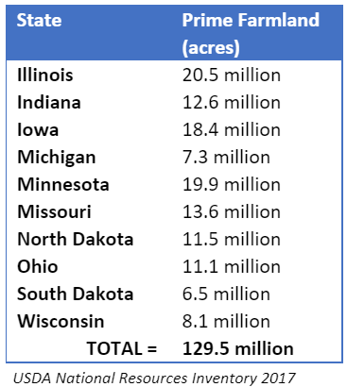
What is prime farmland and how much is there?
Prime farmland is defined by the U.S. Department of Agriculture as “land that has the best combination of physical and chemical characteristics for producing food, feed, forage, fiber, and oilseed crops and is available for these uses.” The USDA National Resources Inventory takes stock of existing prime farmland, revealing that there are ample acres of usable farmland in the Midwest for both the food and energy sectors.
Do renewables require prime farmland?
No; while solar and wind do require many of the same land qualities as crops, they do not specifically require prime farmland for success. However, limiting use of prime farmland can infringe upon private property rights and hinder development of projects that are vital to the success of our energy goals and beneficial to our communities. Developers should consider all possible sites to best serve the community, the environment and our clean energy needs.
Are renewables taking prime farmland from the food sector?
No; about 64% of the 313.7 million acres of prime farmland in the U.S. are considered cropland, which are not exclusive to food production. Other purposes include growth of ethanol-producing crops, urban sprawl and rural transportation. Furthermore, thanks to innovation in biotechnology and seed blends, corn and soybean yields expand even as acreage used for farming decreases. Renewables are cash crops with a small footprint.

Renewables conserve and produce.
Solar and wind can coexist with a variety of conservation efforts. Some community garden and utility-scale solar projects pair beehives with pollinator-friendly native plants and flowers in and around the project area. Currently, three times as many prime farmland acres are used as pastureland for grazing as there would be needed to power the entire grid using solar. Solar and wind systems supplemented by vegetation can be managed by sheep and goat grazing rather than mowing, making our land even more productive. Altogether, conservation and vegetation plans amidst renewables lead to healthier soil, improved water storage and filtration, sequestration of carbon, erosion reduction, habitat preservation and lower local energy costs.

“Natural Resources Conservation Service.” Prime Farmland, www.nrcs.usda.gov/wps/portal/nrcs/detail/null/?cid=nrcs143_014052.
U.S. Department of Agriculture. 2020. Summary Report: 2017 National Resources Inventory, Natural Resources Conservation Service, Washington, DC, and Center for Survey Statistics and Methodology, Iowa State University, Ames, Iowa. https://www.nrcs.usda.gov/wps/portal/nrcs/main/national/technical/nra/nri/results/
“Prime Farmland ‘Top Ten’ States.” National Resources Conservation Service, National Resources Inventory, 1997, Dec. 2000, www.nrcs.usda.gov/wps/portal/nrcs/detail/null/?cid=nrcs143_014052.
Perdue, Sonny, and Hubert Hamer. 1, Part 51, United States Department of Agriculture, 2019, United States Summary and State Data; Geographic Area Series.
“U.S. Energy Information Administration - Eia - Independent Statistics and Analysis.” Use of Electricity - U.S. Energy Information Administration (EIA), 7 Apr. 2021, www.eia.gov/energyexplained/electricity/use-of-electricity.php.
Ong, Sean, et al. NREL - National Renewable Energy Laboratory, 2013, p. V, Land-Use Requirements for Solar Power Plants in the United States.
Benage, Megan, et al. “Guidance for Developing a Vegetation Establishment and Management Plan for Solar Facilities.” Environmental Review of Energy Projects, MN Commerce Department; Division of Energy Resources, Mar. 2021, https://apps.commerce.state.mn.us/eera/web/page/home

